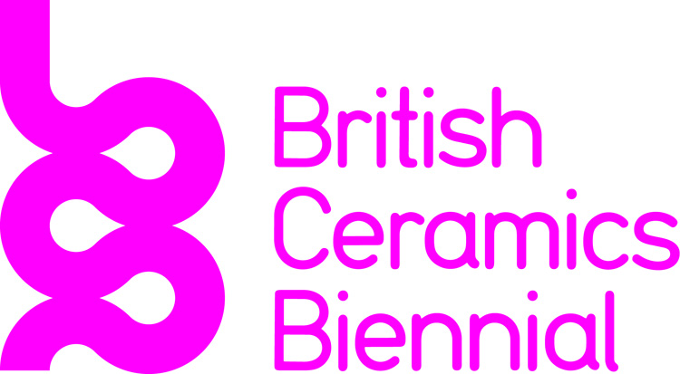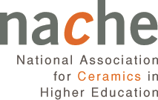

FRESH 2015

“The Fresh exhibition is so much more than a collective graduate show; it is about representing our education, about being present and creating a presence in the ceramics field”
Helen Felcey
Manchester School of Art, NACHE executive
and chair of Fresh 2015 selection panel

The acclaimed FRESH show will be one of the main exhibitions at the fourth British Ceramics Biennial, taking place in Stoke-on-Trent, from 26 September to 8 November 2015.

You are invited to apply for the BCB FRESH 2015 – a prestigious exhibition that celebrates the emerging talent in contemporary British ceramics, in the context of its long history in Stoke-on-Trent.

Deadline for applications: Monday 6 July 2015

What is FRESH?

FRESH is:
- A curated survey exhibition of new ceramic work by recent graduates from UK Higher Education programmes.
- Organised by the British Ceramics Biennial BCB and the National Association of Ceramics in Higher Education (NACHE).

Venue: BCB Exhibition Space
the original Spode factory site, Stoke Town, Stoke-on-Trent
Dates: 26 September — 8 November 2015

FRESH will:
- Promote the high quality work of graduates to a professional and public audience through a combination of visitors to the show, symposium, journal articles and reviews.
- Represent the range of practice of graduates within the field, which is anticipated to include work from across the ceramic spectrum: studio pottery, tableware and industrial design, figurative and abstract sculpture and installation.
- Provide an invaluable launch pad for the exhibitors as they embark on their professional careers.
- Award commendations for three exhibitors demonstrating talent and professional potential in the disciplines of craft, design and fine art.

Timetable

January-5 July Call out for applications
6 July Deadline for submissions
July FRESH selection panel meets and successful candidates informed
1 September Deadline for delivery of all work to exhibition venue
25 September Festival launch night
26 September FRESH Exhibition opens to public
October FRESH commendations event
8 November FRESH Exhibition closes to public
November Collection / dispersal of all work

FRESH application 2015
2015

The application process

The selection panel will choose up to 30 artists’ work to be included in the exhibition. The exhibition will be curated by the BCB and the NACHE Executive. Whilst there is no charge made for submission or exhibition, applicants will be responsible for the delivery and collection of their work, by arrangement.

All applicants must be graduates (BA, MA) of UK higher education universities and colleges who graduated in 2014 or 2015. Applications will be considered from individuals whose primary medium is clay and whose work is based on the exploration of ceramic process.

Send to

Send email/upload your completed application form, with up to 6 images of recent work (300dpi minimum, via email or open link to cloud platform), and a short CV to info@britishceramicsbiennial.com, with the subject heading ‘FRESH 2015 Application’.

Alternatively if this is not possible, you can post to: FRESH 2015 Application, British Ceramics Biennial, Staffordshire University, Faculty of Arts Media and Design, College Road, Stoke-on-Trent ST4 2DE.

FRESH Application
2015 form

First name
Surname
Trading name (if applicable)
Postal address
Studio address (if different)
Telephone
Email
Web/blog address (if applicable)
Higher Education institution
Qualification
Date of graduation

Have you provided content on a CD/DVD? Yes   No 
Have you provided a summary CV? Yes   No 
Have you provided information by other means? Yes   No 
(please state below if answered Yes)

Note: All submission materials; must be marked with your name and contact details.

List of Illustrations
Dimensions for proposed work can be approximate.
Please complete and expand up to 6 listings as required, particularly Description/Title.
1 | Date
 | Media
 | Description/title
 | Dimensions

2 | Date
 | Media
 | Description/title
 | Dimensions

3 | Date
 | Media
 | Description/title
 | Dimensions

4 | Date
 | Media
 | Description/title
 | Dimensions

5 | Date
 | Media
 | Description/title
 | Dimensions

6 | Date
 | Media
 | Description/title
 | Dimensions

Signed
Date

Frequently asked questions

Who is eligible?
All applicants must be graduates of UK higher education universities and colleges who graduated in 2014 or 2015. Applications will be considered from individuals whose primary medium is clay and whose work is based on the exploration of ceramic process.

Can post-graduate students apply?
Yes, if they comply with the above criteria.

We work as a partnership /company. Can we make a collective application?
Yes.

Are there age restrictions?
No.

How many images / works can I submit?
A maximum of six — these may include illustrations of process and details of work.

What media are eligible for entry?
All media are eligible providing the ‘primary medium is clay and the work is based on the exploration of ceramic process’.

Can these be composite works, utilising materials other than clay?
Yes, providing the primary medium is clay and the work is based on the exploration of ceramic process.

Do these all need to be new work?
Any work submitted must have been made in the period September 2013-August 2015.

Is there a size restriction?
No, not at this stage — but please provide dimensions of all work submitted proposed for exhibition.

I graduated from a UK institution, but live and work abroad. Can I apply?
Yes

I am a UK resident, but design for a non-UK company. Can I apply?
Yes.

I work as an in-house designer for a ceramics company. Can I apply as an individual?
Yes, with the permission of your employer and providing that you are the credited designer of the work submitted.

I can’t download an application form. What do I do?
Please contact: Iain Cartwright, email iain@britishceramicsbiennial.com, and give your postal address.

How do I send my application?
Either electronically (email info@britishceramicsbiennial.com) or by post to FRESH 2015 Application, British Ceramics Biennial, Staffordshire University, Faculty of Art Media and Design, College Road, Stoke-on-Trent ST4 2DE.

